**Day_1**

**Assignment 1: Draw your Home Network Topology and explain how you are accessing the RPS Lab environment.**

**ANS:**

1. **Drawing Home Network Topology:-**

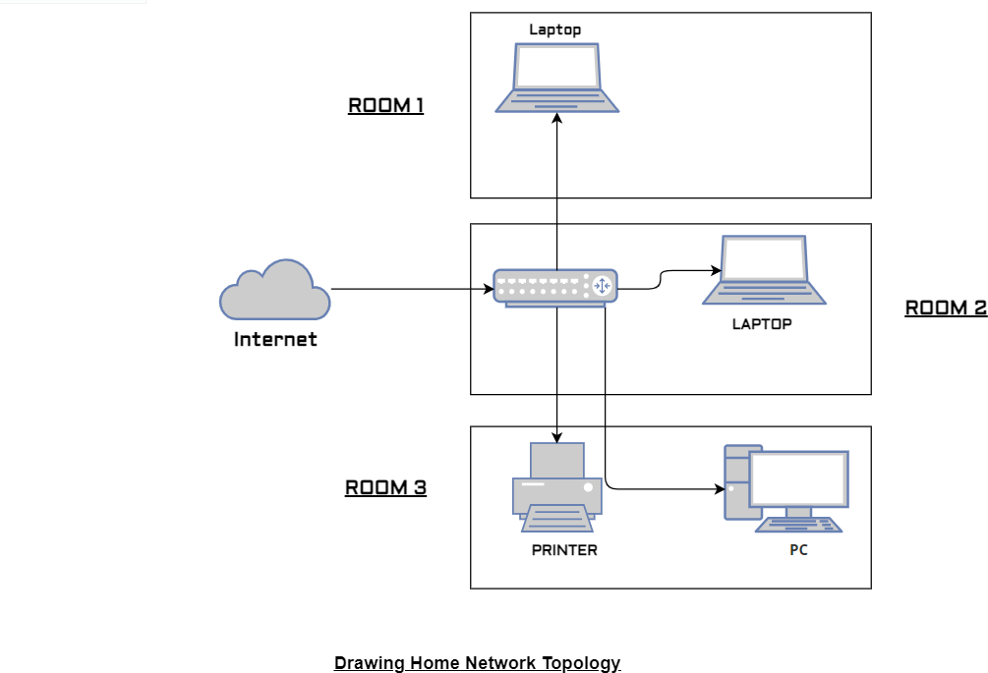

**Ii.** Students can access the college lab environment in several ways, depending on the setup and resources provided by the college. Here are some common methods:

**On-Campus Labs:** Many colleges have physical computer labs equipped with desktop computers or workstations where students can access specialized software and tools required for their courses. Students typically visit these labs on campus and use the provided computers to complete assignments, conduct experiments, or work on projects. Access to on-campus labs may be available during designated hours or by reservation. **Remote Desktop Access:** Some colleges provide remote desktop access to lab computers, allowing students to connect to lab machines from their own devices, such as laptops or personal computers, using remote desktop software. This enables students to access lab resources and software from anywhere with an internet connection, providing flexibility and convenience, especially for distance learning or when physical access to campus is limited. **Virtual Desktop Infrastructure (VDI):** Colleges may deploy virtual desktop infrastructure, where virtual machines running lab environments are hosted on centralized servers.

Students can access these virtual desktops using thin client applications or web browsers, allowing them to interact with lab resources and software without the need for powerful

hardware on their end. VDI offers scalability and centralized management, making it easier for colleges to provide consistent lab experiences to students across different locations.

Cloud-based Labs: Some colleges leverage cloud computing platforms to create virtual lab environments that students can access over the Internet. These cloud-based labs offer scalability, flexibility, and on-demand access to resources, allowing students to perform experiments, run simulations, or practice skills using cloud-based infrastructure and services. Cloud labs can be particularly beneficial for courses involving hands-on experience with modern technologies and platforms.

**Lab Kits or Software Downloads:** In some cases, colleges may provide lab kits containing hardware components, software packages, or simulation tools that students can use for hands-on learning outside of traditional lab settings. Students may also be required to download and install specific software applications on their personal devices to replicate the lab environment for coursework or projects.

Overall, colleges employ a variety of methods to provide students with access to lab environments, catering to different learning styles, preferences, and logistical constraints. The choice of access method may depend on factors such as course requirements, technology infrastructure, and the preferences of instructors and students.

**Assignment 2: Identify a real-world application for both parallel computing and networked systems. Explain how these technologies are used and why they are important in that context.**

**ANS:**

1. **Parallel computing:-** Parallel computing is a type of computation in which many calculations or processes are carried out simultaneously. Large problems can often be divided into smaller ones, which can then be solved at the same time.
   * **Real-world application for parallel computing:-**

**Weather Forecasting:** Weather forecasting requires complex mathematical models to predict future weather conditions accurately. These models involve simulating the behavior of the atmosphere, ocean, and other environmental factors. Parallel computing is essential in weather forecasting because it allows meteorologists to divide the computational workload among multiple processors or computers, enabling faster simulations and more detailed predictions. By leveraging parallel computing, weather forecasting agencies can provide more timely and precise forecasts, which are crucial for various industries such as agriculture, transportation, and emergency management.

Ii. **Networked systems:-** A networked system is a computational system that connects networks or an end system to a network. It's made up of many computing components that are linked through a network and use hardware and software to communicate.

* + **Real-world application for networked systems:-**

**Monitoring and Control:** Sensors installed throughout the grid continuously monitor parameters such as voltage, current, power quality, and equipment status. This data is transmitted over the network to control centers where operators can analyze it in real time and take corrective actions to ensure the efficient operation of the grid.

One real-world application that integrates both parallel computing and networked systems is distributed computing for scientific research, such as in the field of bioinformatics.

**Identify a real-world application for both parallel computing and networked systems:-**

In bioinformatics, researchers deal with vast amounts of genomic data that require substantial computational power for analysis and processing. Parallel computing divides these massive datasets into smaller chunks and distributes them across multiple processors or nodes in a networked system. Each processor works on its assigned portion of the data simultaneously, significantly reducing the time required for computation compared to sequential processing.

Additionally, networked systems enable communication and coordination between these distributed computing resources. Data can be transferred between nodes efficiently, allowing for collaborative analysis and aggregation of results. Networked systems also facilitate the scalability of computational resources, allowing researchers to expand their computing infrastructure by adding more nodes as needed.

The importance of parallel computing and networked systems in bioinformatics lies in their ability to accelerate scientific discovery. By harnessing the combined computational power of multiple processors and coordinating them through networked systems, researchers can tackle complex analyses and simulations that would be impractical or impossible with traditional computing approaches. This enables advancements in areas such as genome sequencing, protein structure prediction, drug discovery, and personalized medicine, ultimately leading to improved understanding and treatment of diseases.